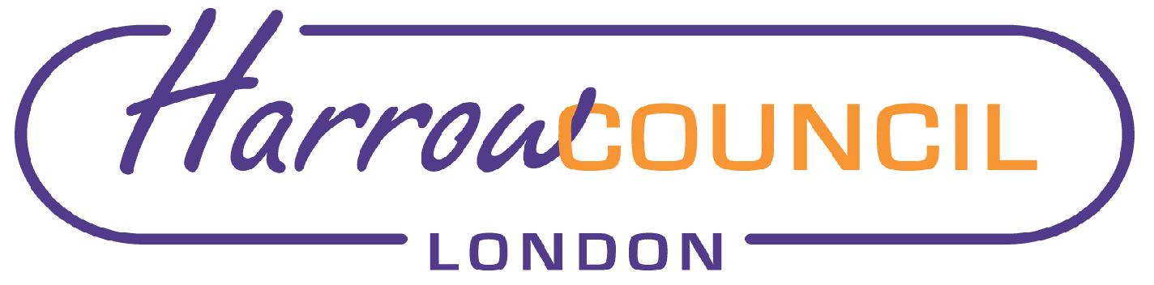

Governance, Audit, Risk Management and Standards Committee – 24 January 2023

Reference from Cabinet – 8 December 2022

- Treasury Management Mid-Year Report 2022/23

RESOLVED: That

(1) the Treasury Management Mid-Year Review for 2022/23, be noted; and

(2) the report be referred to the Governance, Audit, Risk Management and Standards Committee for review.

Reason for Decision: To keep Members informed of the Treasury Management activities and performance to date for 2022/23, promote effective financial management and comply with regulations issued under the Local Government Act 2003, the CIPFA Code of Practice on Treasury Management, and the CIPFA Prudential Code for Capital Finance, along with meeting the requirements of the Council’s Financial Regulations.

For Consideration

Background Documents:
Cabinet Agenda – 8 December 2022

Contact Officer:
Nikoleta Kemp, Senior Democratic and Electoral Services Officer
Tel: 07761 405 898
nikoleta.kemp@harrow.gov.uk

